**WEB APPLICATION DEVELOPMENT LAB**

**19-12-2024**

Eshwar Deshmukh Chavan

HU22CSEN0100999

Webpage where JavaScript is used to display your name and roll number inside a box when a button is clicked, utilizing the CSS box model for layout and styling

**Before Clicking**

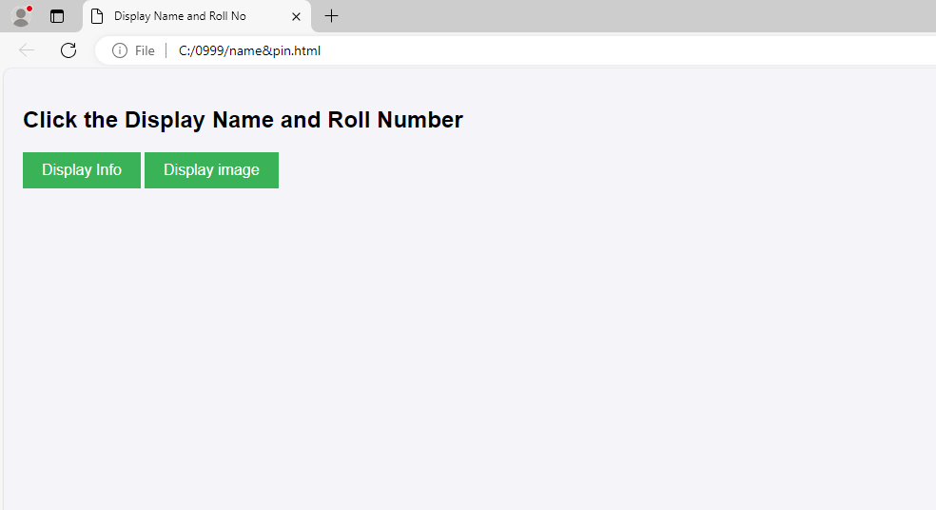

**After Clicking**

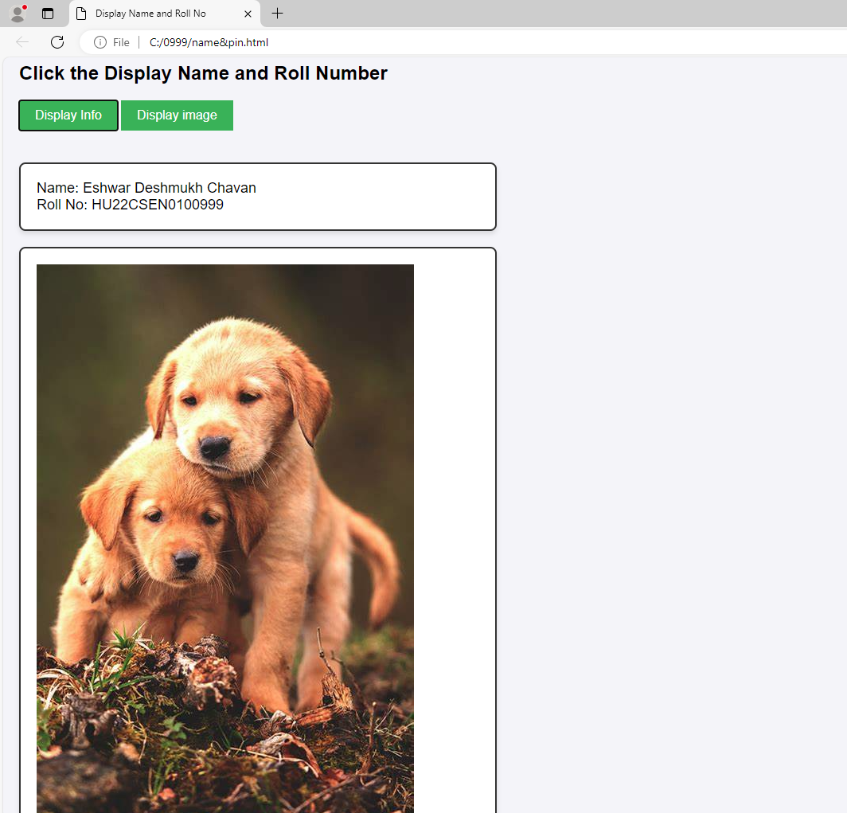

HTML Code:

<!DOCTYPE html>

<html lang="en">

<head>

<title>Display Name and Roll No</title>

<link rel="stylesheet" href="styles.css">

</head>

<body>

<h2>Click the Display Name and Roll Number</h2>

<button onclick="displayInfo()">Display Info</button>

<button onclick="display()">Display image</button>

<div class="output-box" id="outputBox">

<p id="name">Name: Eshwar Deshmukh Chavan</p>

<p id="rollNo">Roll No: HU22CSEN0100999</p>

</div>

<div class="box" id="boxx">

<img src="DOG.jpg" >

</div>

<script>

function displayInfo() {

const outputBox = document.getElementById('outputBox');

outputBox.style.display = 'block';

}

function display() {

const outputBox = document.getElementById('boxx');

outputBox.style.display = 'block';

}

</script>

</body>

</html>

CSS code:

body {

font-family: Arial, sans-serif;

margin: 0;

padding: 20px;

background-color: #f4f4f9;

}

button {

padding: 10px 20px;

font-size: 16px;

background-color: #4CAF50;

color: white;

border: none;

cursor: pointer;

margin-bottom: 20px;

}

button:hover {

background-color: #4ad5ee;

}

.output-box {

display: none;

padding: 20px;

margin-top: 20px;

width: 600px;

border: 2px solid #333;

background-color: #fff;

box-sizing: border-box;

border-radius: 8px;

box-shadow: 0px 4px 6px rgba(0, 0, 0, 0.1);

}

.output-box p {

font-size: 18px;

margin: 0;

}

.box {

display: none;

padding: 20px;

margin-top: 20px;

width: 600px;

border: 2px solid #333;

background-color: #fff;

box-sizing: border-box;

border-radius: 8px;

box-shadow: 0px 4px 6px rgba(0, 0, 0, 0.1);

}